**PYTHON ASSIGNMENT**

**Ques1) What is JPython & CPython?**

**Ans)**

**Jython:**

Jython is an implementation of the Python programming language that can run on the Java platform. Jython programs use Java classes instead of Python modules Jython compiles into Java byte code, which can then be run by Java virtual machine. Jython enables the use of Java class library functions from the Python program. Jython is slow as compared to Cpython and lacks compatibility with CPython libraries.

**CPython:**

CPython is the reference implementation of the Python programming language. Written in C and Python, CPython is the default and most widely used implementation of the language. CPython can be defined as both an interpreter and a compiler as it compiles Python code into bytecode before interpreting it.

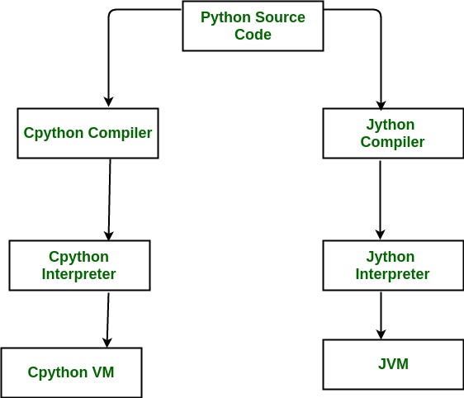

**Ques2) Basic difference between Python2 & python3**

**Ans)**

* Python 3 syntax is simpler and easily understandable whereas Python 2 syntax is comparatively difficult to understand.
* Python 3 default storing of strings is Unicode whereas Python 2 stores need to define Unicode string value with "u."
* Python 3 value of variables never changes whereas in Python 2 value of the global variable will be changed while using it inside for-loop.
* Python 3 exceptions should be enclosed in parenthesis while Python 2 exceptions should be enclosed in notations.
* Python 3 rules of ordering comparisons are simplified whereas Python 2 rules of ordering comparison are complex.
* Python 3 offers Range() function to perform iterations whereas, In Python 2, the xrange() is used for iterations.

**Ques3) Difference between ASCII & unicode**

**Ans)**

1. ASCII uses an 8-bit encoding while Unicode uses a variable bit encoding.  
2. Unicode is standardized while ASCII isn’t.  
3. Unicode represents most written languages in the world while ASCII doesn’t.  
4. ASCII has its equivalent within Unicode.